

|  |
| --- |
|  |

|  |
| --- |
|  |
| **Central Intelligence Agency** |
| Emerging Threat Data Packet |

**CENTRAL INTELLIGENCE AGENCY DATA PACKET**

—In 2004, CIA began to surveil Ibraham Gulek as a result of his association with known Al-Qaeda operatives. Gulek is suspected of leading operative training schools for Al-Qaeda in Afghanistan from 2005-2010 and publicly pledged allegiance to ISIS following the split between Al-Qaeda and ISIS in 2014. Gulek’s current location is unknown. It is suspected he is coordinating ISIS operations in eastern Turkey.

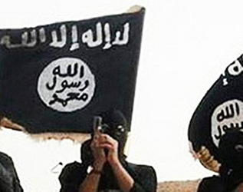—Noted ISIS leader and religious cleric Ibrahim Gulek has released a new propaganda video via ISIS’s social media organization featuring beheadings of individuals deemed by ISIS to be apostate Muslims. In the video, Gulek calls for Muslims who are unable to join the fight for their caliphate in the Middle East to wage attacks on the “Roman crusaders” in the West.

—Supervising analysts at the CIA have noted ISIS attacks in its claimed provinces have been tactically conventional; using explosives, rifles etc. In contrast, ISIS-inspired attacks in the United States and Europe have been more ad-hoc, likely as a result of limited resources. These attacks often use knives, handguns, and regular vehicles to cause casualties.

Pictured: Believed to be Ibraham Gulek in an early ISIS propaganda video

—2015 Around this time it is suspected that U.S. Army veteran Edward Sanson quietly converted to Islam and took the name “Ahmed Mahmood al Rahman”. A new twitter account under this name is created in late 2015. The “al Rahman” account quickly establishes a network with known ISIS recruiters and sympathizers.

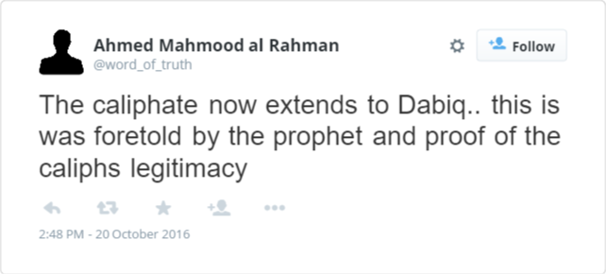

—06/01 As part of a preliminary investigation at to possible radicalization of 16-year-old Habban Roobo, the FBI has reached out to CIA for any information concerning her parents before emigrating to the U.S. from Trinidad. CIA has no records or information on the Roobo family.

—06/02 The FBI has alerted intelligence officials at CIA that Sarihan Aksit is planning to travel to his native Turkey. His stated reason is to visit family. Aksit is the subject of a basic investigation by the FBI following reports of possible radicalization.

—06/04 CIA officers attempt to surveil Sarihan Aksit intermittently during his visit in Eastern Turkey, near the border with Syria. For two days, he is not observed in the area around his hotel room or family residence. CIA personnel cease surveillance on 06/05.

—Near the end of this month, the Pope will begin a second tour of the Americas; first visiting Atlanta, Georgia and then several major U.S. cities before moving on to Latin America. Field agents have been deployed to secure planned locations he will visit. It has been reported that protests from several different political activist groups have been planned for when the Pope lands at Hartsfield–Jackson Atlanta International Airport (ATL).

—Open-source analysts have disseminated a report saying that, historically speaking, individuals with open and explicit sympathy with ISIS, especially on social media, are not guaranteed to engage in violent behavior. Included in the report is a complete lack of profile for a typical radicalized individual. There has been precedent for all ages, genders, and work history; a notable example being the 2009 Fort Hood shooting by a current Army Major.

—06/07 A very sophisticated and high-profile arms robbery was reported in Jacksonville, Fl. Local law enforcement and federal agencies are currently working to try to ascertain to identity of the perpetrators. Officials at the CIA cannot find intelligence in recent records to corroborate the theory of an international terrorist organization being responsible for the heist.

—06/13 SIGINT analysts have collected and translated a conversation between Ibrahim Gulek and ISIS leaders in Aleppo, Syria that was placed on 06/08. During the call, Gulek stated that the operatives working on their behalf in the United States have had to make major changes in their plans but will not require any more support to complete their attack. The nature of Gulek’s support to the perpetrator(s) is unclear.

