|  |
| --- |
|  |
| **Department of Homeland Security** |
| Emerging Threat Data Packet |

|  |
| --- |
|  |



**DEPARTMENT OF HOMELAND SECURITY DATA PACKET**

—Baghdad, Iraq— At an anonymous tip office which is open to the public and manned by American military personnel, an individual claims to have overheard a phone conversation between ISIS leaders about an operative travelling from the West to Syria to receive instructions for an attack in the United States. SIGINT sources actively monitoring selected ISIS leaders’ communications cannot confirm this claim. The specialist who received the tip noted in their report that the individual was eager to receive payment for his information quickly as he was late on his rent.

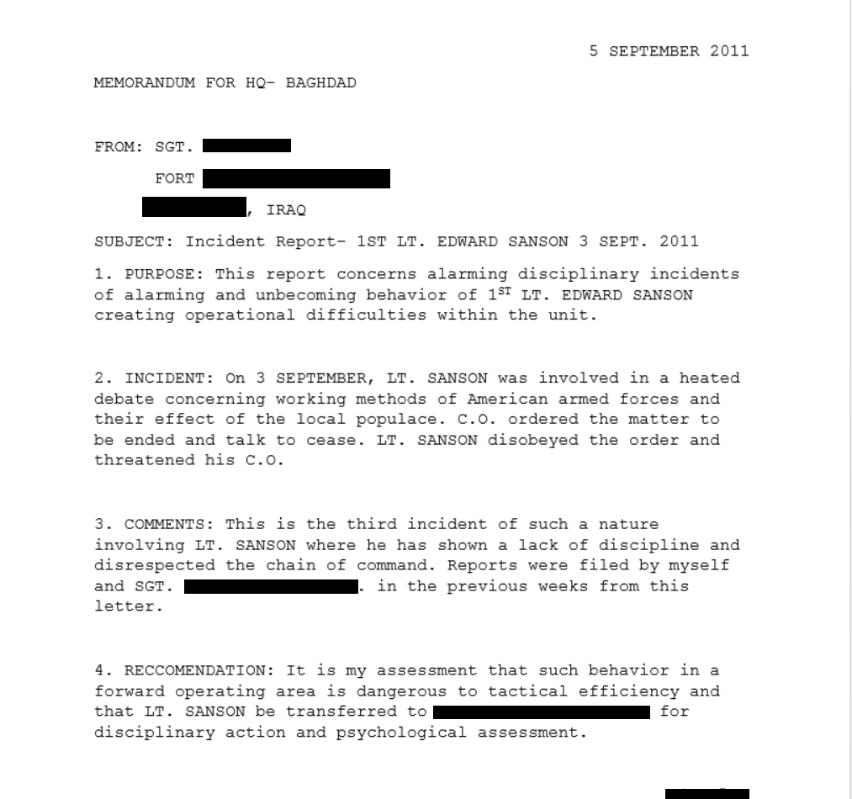—Army Intelligence and Records: Edward Sanson is a military veteran of the US Army, completing a tour in Iraq in 2011 where he showed aptitude in marksmanship, and was considered a candidate for sniper training. During his tour, it is known he grew increasingly dissatisfied with US Foreign policy in the region and was reported to have made negative comments concerning the use of Predator Drones.

Additionally, he is reported to have been involved in a physical confrontation with a fellow soldier; Service Number 54-000-553. Both parties refused to discuss the nature of the altercation. After his tour, Edward returned to S. Carolina where he enrolled in the local community college.

—Aksit has been placed on the national No-Fly List.

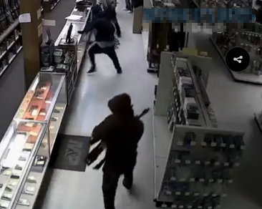—06/07 Special agents at the ATF are investigating a theft in Jacksonville, Fl at a large gun store and shooting range in the early hours of 06/07. The five perpetrators in ski masks drove a stolen van through the shopfront door and stole approximately $150,000 in guns and body armor. Many of the weapons were semi-automatic AK-47 rifles and various models of semi-automatic handguns. The van was found abandoned on an isolated stretch of road with no leads as to the identity of the thieves found. Investigators who have analyzed the surveillance footage say the robbery appears to have had a great deal of planning and thought. Florida state troopers have set up checkpoints throughout the state’s highway system looking for suspicious activity in an attempt to recover the weapons and arrest the perpetrators.

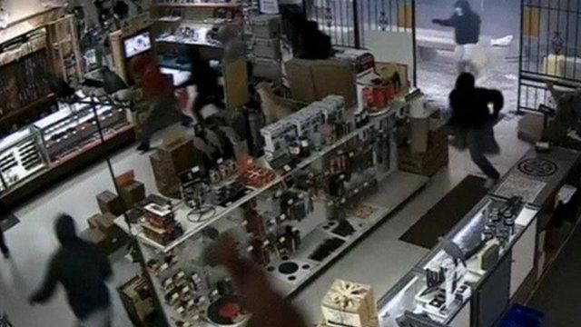

—06/15 The Department of Homeland Security has received a tip from a commercial farm supply retailer in northern Georgia. The owner of the business reported an individual was attempting to buy a large amount of fertilizer that contained ammonium-nitrate. While ammonium-nitrate is not a controlled substance, it has been used in the past by domestic terrorists as a vital element to create bombs. Because of this, the ATF as part of the war on terror has made efforts to inform and educate fertilizer suppliers on how to spot suspicious activity by their customers. The business owner reported that when asked specifics about the customer’s farm such as acreage, the individual was evasive and seemed to not be knowledgeable about farming practices. When the farm supply owner requested a copy of the customer’s business license and driver’s license, the individual hastily found an excuse to leave and left the supply depot. When asked to describe the individual, the owner stated, “He was young. Maybe in his early 20s.” When asked the individual’s ethnicity, “I don’t know. White. He was normal.” The supply depot has no security cameras where the conversation took place.

—(06/21) On 06/20, special agents from the Drug Enforcement Agency raided a dockside warehouse in Brunswick, Georgia that was suspected of being a part of a regional narcotic distribution network. During the subsequent search of the warehouse, agents found a stash of weapons similar to those stolen in Jacksonville, Fl on 06/07. However, identifying marks such as serial numbers have been filed off so confirmation that these are the same weapons is not possible. In addition, if these weapons are the same as those stolen, not all would be able to be accounted for following this raid as the number of weapons seized in this operation is less than those stolen. The renters of the warehouse have previously been suspected of drug trafficking and are unwilling to tell investigators how they obtained the weapons cache.