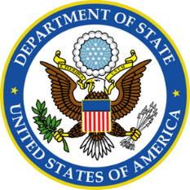

|  |
| --- |
|  |
| **Department of State** |
| Emerging Threat Data Packet |

|  |
| --- |
|  |

**DEPARTMENT OF STATE DATA PACKET**

—Ibrahim Gulek is an Iraqi citizen from a wealthy family who has previously received Western-styled education at a university in Egypt studying mechanical engineering. Gulek has traveled several times to the United States to attend conferences and may have close relationships with academics in the northeastern United States.

—Decision makers have informed the Department of State of an unprecedented call to action by ISIS leaders to attack “crusaders” in the West. Embassy and consulate staff are encouraged to report any suspicious activity around facilities. A travel advisory has not been issued to U.S. citizens however, as there is no indication as to an area or means of the hypothetical attack, if any.

—Security personnel in DoS facilities who are concerned about an ISIS-inspired attack have been distributed a fact sheet of previous attacks considered to be ISIS-inspired by The Department of State Bureau of Intelligence and Research. Incidents within ISIS’s desired area of expansion (i.e. the Arab peninsula and North Africa) have used relatively conventional military tactics, such as utilizing rifles; even employing weapons still left after the fall of the Soviet Union. Attacks in the West, however (i.e. Europe and North America) have utilized more unconventional tactics like random stabbings and legally acquired handguns.

—Habban Roobo is the 16-year-old daughter of Trinidadian immigrants. She was born in the United States in Charlotte, North Carolina and attends a local high school there.

—2014, ISIS takes Fallujah. Army veteran Edward Sanson’s comments on social media sites like twitter illustrate a view that this is result and consequence of US action. Around this time, Sanson is disciplined for an outburst during class at a community college following his discharge in which he verbally threatened a fellow student over a heated discussion about newspapers and artists participating in a “Draw Mouhammed Day” in response to threats by extremists. It is believed Sanson abandons his formal education at this point.

—Sarihan Aksit applies for an American passport. On the form, he states he is traveling to his native Turkey from June 2nd to 5th. In a follow-up email, when asked why he does not use his Turkish passport, Aksit claims he lost it two years ago.

— Near the end of this month, the Pope will begin a second tour of the Americas; first visiting Atlanta, Georgia and then several major U.S. cities before moving on to Latin America. Field agents have been deployed to secure planned locations he will visit. It has been reported that protests from several different political activist groups have been planned for when the Pope lands at Hartsfield–Jackson Atlanta International Airport (ATL.)

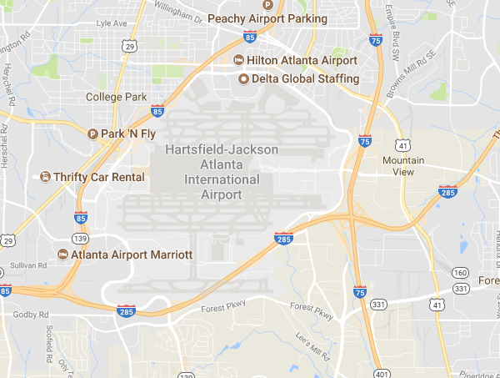

—06/10 The Department of Homeland Security has placed a records request for Sarihan Aksit to the Department of State. The reason for the request is regarding an inquiry as to whether to place Aksit on the do-not-fly list.

—06/11 The State Department has been informed that Sarihan Aksit did not return on his scheduled flight back to the United States.

—06/12 The FBI has placed a records request for Sarihan Aksit’s cousin Abdullah Oz to the Department of State regarding an investigation. Other than biographical information provided with his passport application, no notable information is apparent.

—06/14 Embassies are informed of intelligence relating to an imminent attack in the West by ISIS instructed individual(s). This information was shared by analysts at CIA headquarters in Langley. No more information is included in the report.

—06/14 Local authorities in Georgia have reached out to the State Department concerning local minor Habban Roobo. Roobo’s parents are concerned that she may be vulnerable to radicalization by ISIS’s social media apparatus and may attempt to leave the country. In response to local law enforcement’s request for assistance, personnel in the Department of State have said that after Roobo’s parents have taken possession of her passport, she can be placed on a list to ensure she cannot apply to have it replaced so as to leave the country.

—06/22 Habban and Johro Roobo have been reported as missing persons. Johro Roobo’s and her sister’s passports are missing following a police investigation. The FBI has opened an active investigation and is coordinating with the State Department as it is believed they are a flight risk.

—06/28 German authorities have detained two girls in Frankfurt travelling with American passports. One named Johro Roobo and another named Hiba Roobo though local authorities claim that upon inspection of the passport photo, the person using the Hiba ID does not appear to be the person pictured. The individuals were waiting on a connecting flight to Turkey.