|  |
| --- |
|  |
| **Federal Bureau of Investigation** |
| Emerging Threat Data Packet |

|  |
| --- |
|  |



**FEDERAL BUREAU OF INVESTIGATION DATA PACKET**

—06/01 Turkish-born, Sarihan Aksit has been under low-level surveillance by the FBI as a result of a tip from a concerned citizen at his mosque who claims that Aksit has recently made statements in defense of ISIS and its tactics. Near the end of the routine observation period given to tips of this nature, the FBI was made aware that Aksit had bought a roundtrip plane ticket to Turkey. FBI agents interview Aksit. During this interview, Aksit claims he is traveling Turkey to visit relatives.

—October 2011 U.S. Army veteran Edward Sanson purchased a used Ford F-150 pick-up truck, co-signed with father.

—06/07 Edward Sanson purchases a high-powered hunting rifle - Ruger Modell 44 (Carbine) from a local gun store. The FBI was made aware by the gun store owner who said that Sanson had a large amount of cash on him and was worried about possible criminal affiliation.

—06/07 Sarihan Aksit was not on his scheduled return flight to the United States. FBI officials have reached out to the State Department as well as authorities in Turkey with no information to report.

—Near the end of this month, the Pope will begin a second tour of the Americas; first visiting Atlanta, Georgia and then several major U.S. cities before moving on to Latin America. Field agents have been deployed to secure planned locations he will visit. It has been reported that protests from several different political activist groups have been planned for when the Pope lands at Hartsfield–Jackson Atlanta International Airport (ATL).

—06/08 Following forensic analysis at Sarihan Aksit’s cell phone records, specifically what cell towers his phone pinged in the days leading to his trip to Turkey, analysts have concluded that Aksit made a day trip to the Georgia area. Officials have confirmed that Aksit’s cousin, Abdulah Oz, lives in Georgia.

—06/12 Abdullah Oz has recently been reported via tipline by a concerned classmate. She states that Abdullah has been acting strangely and making alarming statements. With Abdullah Oz’s classmate’s permission, FBI field agents are given access to her social networking account. Posing as the classmate, agents had this conversation with Abdullah:

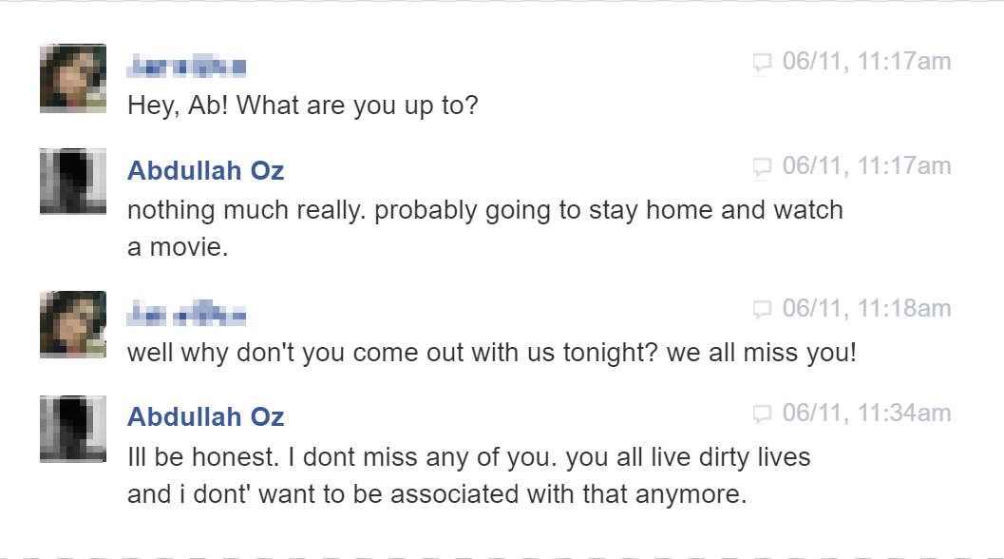

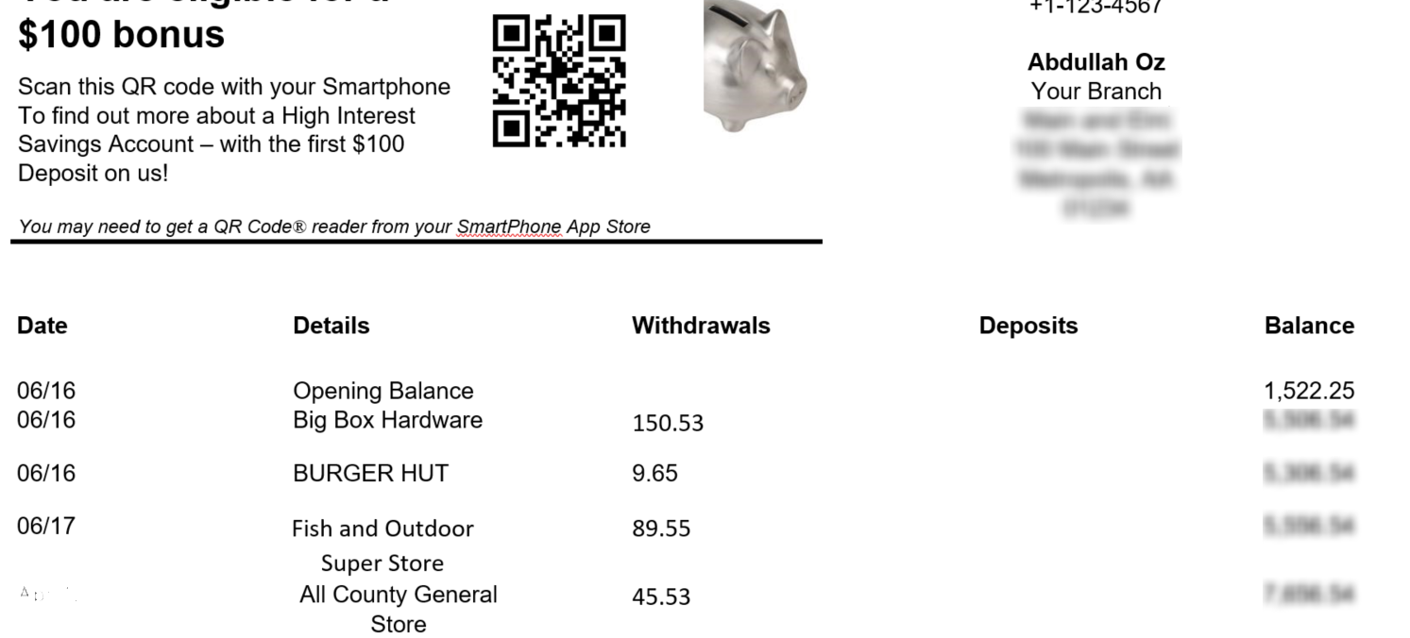—06/20 The following is a bank statement of Abdullah Oz’s account covering activity between 06/16 and 06/18:

—06/20 The following is a conversation recorded between Abdullah Oz and a classmate:

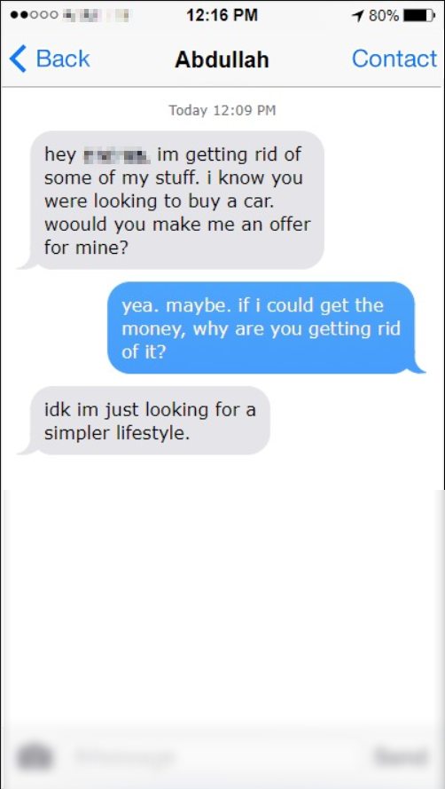

—06/22 Following the reports of Habban and Johro Roobo as missing persons, the FBI has decided to open an active investigation. A search of Johro’s room discovered that her passport is missing. Her parents report her sister’s passport as missing as well. On 06/18 Habban Roobo appears to have withdrawn all money ($875) from her bank account.

—06/25 A driver of a phone-based ride sharing service reports that he dropped two girls similar in appearance to the photos used in the Roobos’ missing persons flyers. According to the ride sharing service’s records, they were dropped off in Atlanta.

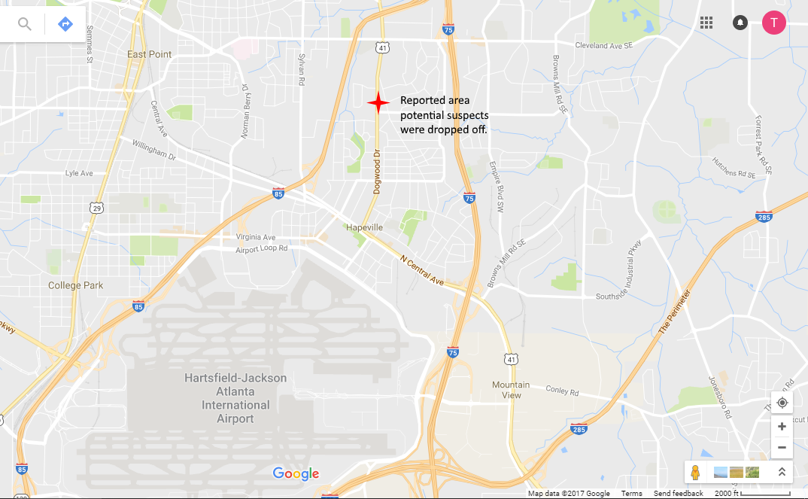

—06/28 The classmate of Abdullah Oz who had previously cooperated with state police and the FBI has reported that Abdullah has been absent from class since approximately 06/20 and none of their mutual acquaintances has been able to provide his whereabouts. Below is a short conversation between Abdullah and the classmate via social media:

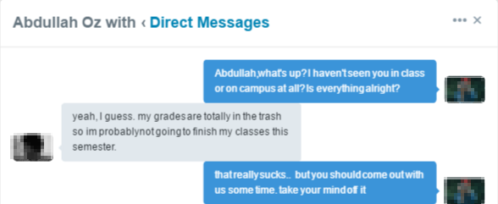

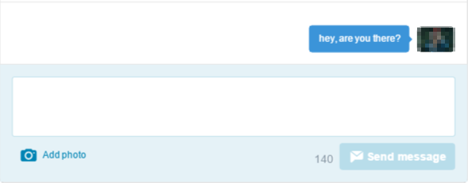

Abdullah has not been observed at his residence or on the university campus in recent days.