

|  |
| --- |
|  |
| NCTC Local Authorities Cadre |
| Emerging Threats Packet |

|  |
| --- |
|  |

**LOCAL AUTHORITIES DATA PACKET**

—Clarke County Public Schools: 06/01 A school principal in Athens, Georgia recently made a report to the parents of 16-year-old high school student Habban Roobo. Roobo’s teachers reported hostile statements Habban had made to other students while discussing current events in the Middle East calling it a “Christian Crusade.”

—Athens, Georgia P.D.: 06/02 Following the report from school, Habban’s parents search her room and computer. During the search, Roobo’s parents find she has been following prominent online ISIS recruiter Halim Baba. The parents subsequently reach out to Athens P.D. for help concerning their daughter.



Roobo’s parents are concerned that Habban is planning on traveling to aid the Islamic State in Syria.

—Georgia State Patrol: 06/08 Responding to NCTC commanders’ requests for more information, Georgia’s state police have informed NCTC that the cousin of Sarihan Aksit, US-born Abdullah Oz aged 21, is a Georgia resident. He was brought to Georgia authorities’ attention when a concerned classmate at his university reported alarming posts Oz had made on social media.





—Georgia State Patrol: 06/08 Cont. [Transcription of previous interview with classmate] “[Abdullah] was never really all that interested in politics or religion when I first met him. He was just a normal kid. […] His grades started slipping and he was really upset that he wasn’t fitting into the social atmosphere at school. That’s when he started to talk about his religion more.”

—Clarke County Public Schools: 06/08 Habban’s parents place her in a counseling program run by the county public schools. What follows is an excerpt of the counselor’s notes:

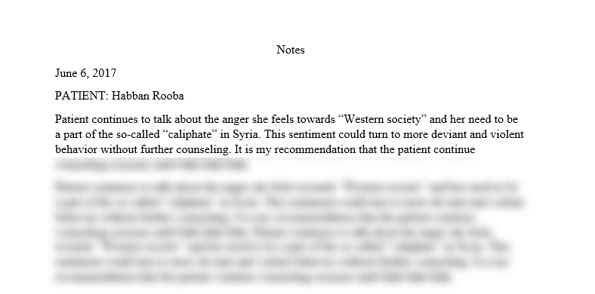

—Highway Patrol: 06/10 Eyewitnesses describe a Ford F150, following two enlisted soldiers in the Columbus GA area. One soldier described a truck following him for some distance during her drive from Atlanta back west and pulling into a gas station right behind her car but never getting out to fill his tank. Another soldier said he saw the same truck on parked on Highway 185 close route 280 for two nights straight with no lights on. Reports were made to local military police.

—Columbus P.D. Report: 06/10 Eyewitness confirms he sold someone matching Sanson’s description a “Bushmaster M4 Carbine” outside of a gun show for cash. No paperwork or identification from the purchaser was requested.

—Atlanta PD: 06/13 As an extra precaution during the week of the Pope’s visit, and as a result of state resources being allocated to his security, Atlanta police have taken the lead in ensuring the security for the upcoming ATL Diversity Cultural festival being held in Piedmont Park on July 1st. The urban park is adjacent to downtown and midtown Atlanta. City funds have been allocated to pay for a private security firm to patrol and secure the perimeter of the festival site so that Atlanta police can be present at the entrances to check bags and observe any suspicious activity. The festival venue is bordered by city streets with a high volume of vehicle traffic as well as pedestrians.

—Winterville, Georgia P.D.: 06/13 The parents of Johro Roobo, Habban Roobo’s 15-year-old cousin, have discovered that Johro is also following online ISIS recruiter Halim Baba.

—Athens, Georgia P.D.: 06/16 Habban Roobo’s parents confiscate her passport.

—Athens, Georgia P.D.: 06/19 Habban Roobo’s parents report Habban as a missing person. Her cousin Johro is missing as well. Federal authorities have been notified.

—Atlanta P.D.: Atlanta P.D. in charge of security during the Pope’s visit have announced that they are planning to search all bags of those planning to protest the Pope’s arrival and are limiting bag sizes to being 14 inches in diameter.

—Georgia State Patrol: 06/20 State police have responded to reports of a prowler around southern Columbus homes. There have been several reported break-ins where the perpetrator has stolen food, clothing, and apparently showered. Searches of the surrounding area have found evidence of recent campsites.

—Spalding County PD: (06/06) Police from rural Spalding County, Georgia, just south of Atlanta, have responded to reports by a local resident of a loud noise that came from a neighboring field to his land. When asked if the noise could have been local hunters poaching out of season the resident responded, “If they were, they must have been shooting with blunderbusses. It was really loud!” The resident said that just prior to hearing the noise he saw a male, visibly agitated running into the woods bordering the field. He says they appeared to be panicked. A search by responding officers was unable to spot any individuals in the field, however, a circular patch of freshly disturbed earth was discovered and some scorching on the surrounding vegetation. The patch was approximately 12 feet in diameter. When officers searched the wooded area the individual ran into, all that was found was a fresh set of tire tracks leading from an adjacent road.

—Atlanta PD: 06/25 The manager of a local hotel in downtown Atlanta made a report to police concerning a seemingly abandoned rental truck in the parking lot of his hotel. The truck was ticketed multiple times by hotel staff for not being a registered guest vehicle. The tickets date back to the 7 June. The manager was alerted by staff and after inspecting the vehicle and concluding it was abandoned, called authorities. The moving truck was traced to a local rental office but Atlanta police could not identify who rented it as the office had already closed for the day. After the truck was impounded, no personal effects were found.