
National Security Agency
Emerging Threat Data Packet

NATIONAL SECURITY AGENCY DATA PACKET
—Noted ISIS leader and religious cleric Ibrahim Gulek has released a new propaganda video via ISIS’s social media organization featuring beheadings of individuals deemed by ISIS to be apostate Muslims. In the video, Gulek calls for Muslims who are unable to join the fight for their caliphate in the Middle East to wage attacks on the “Roman crusaders” in the West.
—For several years, Sarihan Aksit has posted many videos and articles of ISIS propaganda that has resulted in his account being banned several times.
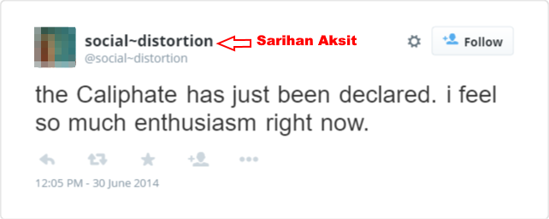
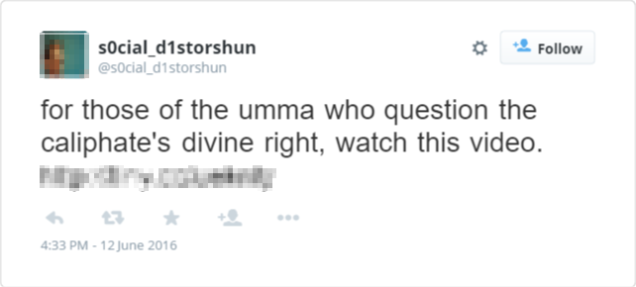
—2011-2013 U.S. Army veteran Edward Sanson began visiting extremist websites during these years and following the rise of ISIS. Twitter activity increased with a growing criticism of US involvement in the region as well as disparaging remarks over US policy towards the inclusion of women in the combat roles, LGBTQ rights and immigration. Communication with his father (mother deceased) becomes sporadic and ends in early 2013.
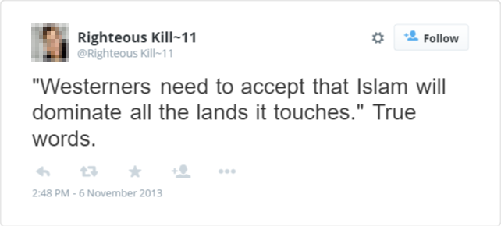
—2015 Around this time it is suspected that Edward Sanson quietly converted to Islam and took the name “Ahmed Mahmood al Rahman”. A new twitter account under this name is created in late 2015. The “al Rahman” account quickly establishes a network with known ISIS recruiters and sympathizers.
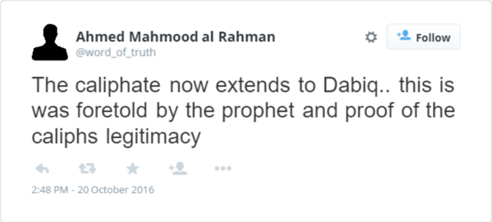
Credit card statements around this time show purchases of handguns at local gun shops.
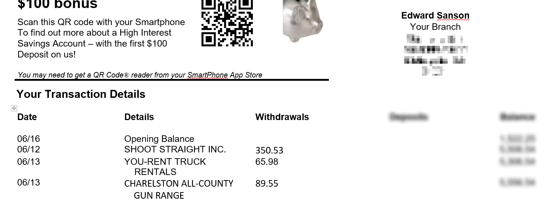
—SIGINT collection apparatus has records indicating Edward Sanson has made several international phone calls to prepaid or satellite phones believed to be in Syria.
—06/13 The following is a recorded SMS text received from Abdullah’s cellular service provider dated 06/07:
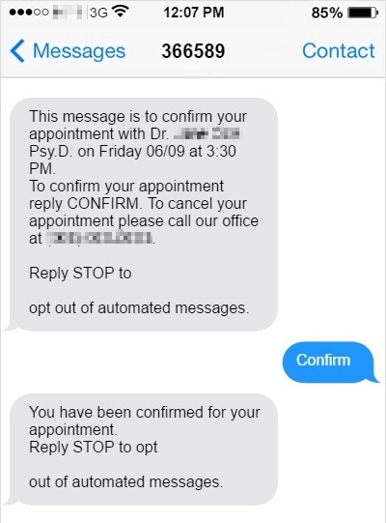
—06/08 NSA analysts have noticed a trend among ISIS fighters in the Middle East in their rhetoric both public and private. Often the language used when referring to Western forces, ISIS commanders will evoke images of encroaching crusaders and Roman pagans attempting to invade the lands of Muslims.
—06/17 Last known credit card transaction for Oz. Notable purchases: Army fatigues from military surplus store, a “North Face Stormbreak 2” outdoor tent.

